>> Intelligent Systems – WG 1 <<

Sets, Graphs, Trees

State-Space Representations

Uninformed Search

Concepts to be known after WG1 :

- Basic concepts of Discrete Mathematics
  - Set theory (union, intersection, complement, disjointness, cardinality)
  - Graphs
  - Trees
- State-Space Representations
  - Initial state
  - Goal test
  - Successor function
- Uninformed Search
  - Terminology search trees
  - Breadth-first search
  - Depth-first search
  - Depth-first iterative deepening

Exercises 1: Naïve Set Theory
Exercise 1a: Given A = {1, 3, 8, 10} and B = {6, 9, 12} for a Universe U={1,3,6,8,9,10,12}. Which of the following statements is/are TRUE?

- B is the complement of A
- A B = ∅
- A and B are disjoint sets
- B ⊂A

Exercise 1b: There are 25 elements in a universal set. If |A| = 10, |B| = 10 and |A  B| = 10, what is the cardinality A union B, formally |A  B|?
- 0
- 10
- 15
- 20

Exercises 2: Graphs
Exercise 2a: List all undirected graphs that have {a,b,g} as their vertex/nodes set. How many directed graphs are there with vertices {c,d}?

G={V,E} where the fully connected graph would have:
E = {{a,a},{a,b},{a,g},{b,b},{b,g},{g,g}}

For each subset of E there is a different graph, i.e. E1 = the empty graph, E2={{a,a}}, E3={{a,a},{a,b}}, E4={{a,a}{a,g}}, etc. In total there are 2⁶ = 64 different graphs.

For a directed graph the fully connected graph would have
E={(c,c),(c,d),(d,d),(d,c)}, so in total 2⁴=16 different graphs.

Exercise 2b: The adjacency matrix of a graph G is the matrix A defined as follows: adjacency for any two vertices u and v,
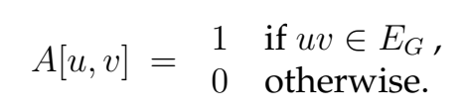
In other words, an adjacency matrix A for a graph G has a 1 if, and only if, there is an edge between nodes u and v, and a 0 otherwise. Write down the adjacency matrix for the graph:
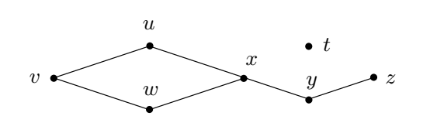
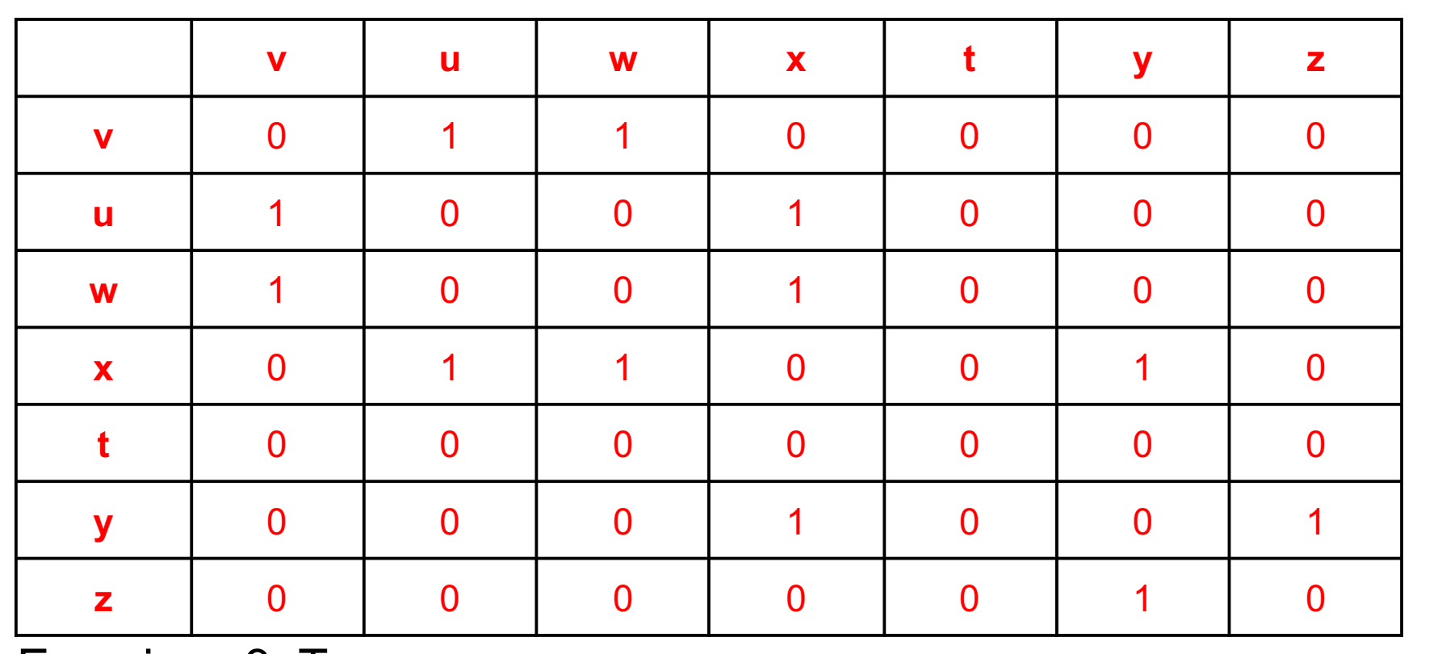

Exercises 3: Trees

Exercise 3: Annotate the following tree with labels: root and the leaves.
- What is the depths of the leaf-nodes, and thus the heights/depths of the tree?
  - 3
- Which are the nodes with the same descendants as children?
  - d,e,f,g,h,i,j,k,l
- Which are the nodes which can be identified uniquely as the child of their parent?
  - g,h (single children)
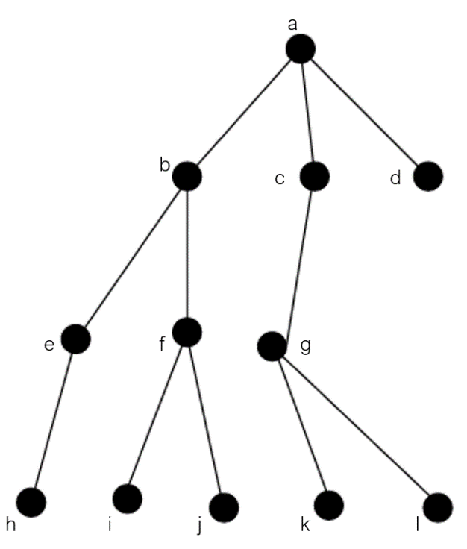

Exercises 4: Representation of State-Space Problems

Exercise 4: Give the initial state, goal test, successor function and cost function for the following problem. Choose a formulation that is precise enough to be implemented.
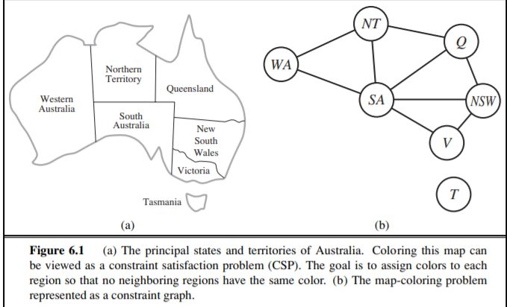
- You have to color the planar map of Australia using only four colors in such a way that no two adjacent regions have the same color.
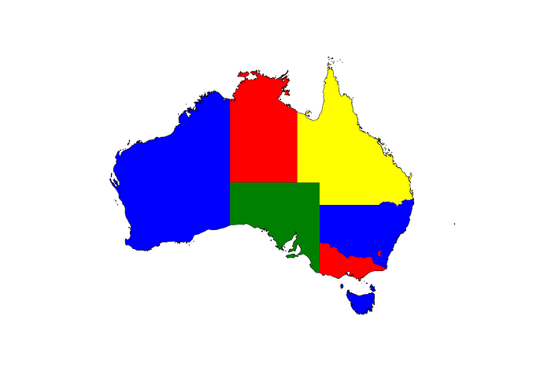

Initial state = state that the agent starts in
goal test = test which determines whether a given state is a goal state
successor function = agent’s options: given a state, it returns a set of <action,
state/successor> pairs, where each state is the state reachable by
taking the action. For example, from the state In(Arad), the successor
function for the Romania problem would return:
{<Go(Sibiu), In(Sibiu)>, <Go(Timisoara), In(Timisoara)>, <Go(Zerind), In(Zerind)>}
cost function = a mathematical formula used to predict the cost associated with a certain action or a certain level of output
One possible answer set:
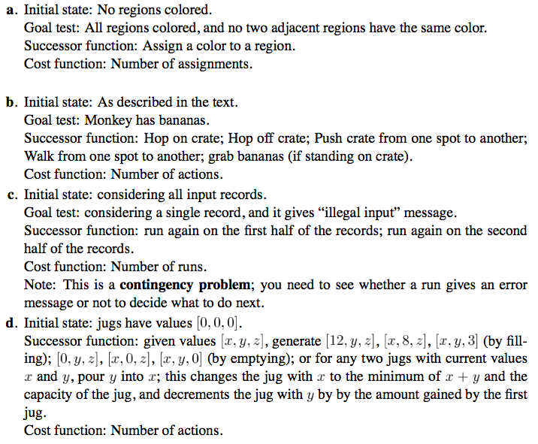

Note: you can represent the problem as a graph colouring problem (regions are vertices, edges between vertices if and only if they are adjacent).
Exercises 5: Uninformed Search
Reminder: the Tree Search algorithm (pseudocode)

Please for the following
function TREE-SEARCH(problem,fringe) return a solution or failure
fringe ← INSERT(MAKE-NODE(INITIAL-STATE[problem]), fringe)
loop do
if EMPTY?(fringe) then return failure
node ← REMOVE-FIRST(fringe)
if GOAL-TEST[problem] applied to STATE[node] succeeds
then return SOLUTION(node)
fringe ← INSERT-ALL(EXPAND(node, problem), fringe)

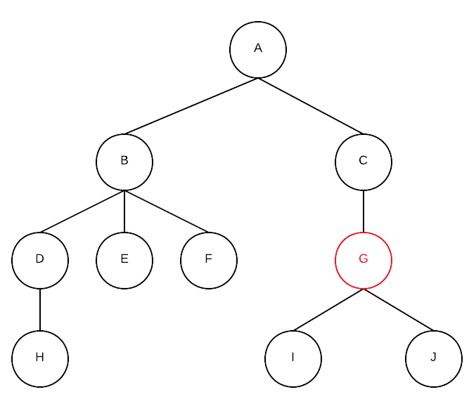
Exercise 5.1: Consider the following state-space diagram, where the lines are directed from top to the bottom, i.e. one can e.g. move from state A to B, but not back from B to A, etc.

- When you apply breadth-first search, which nodes will be visited before the goal node ‘G’ has been found? ABCDEFG
The successor nodes are added at the end of the list, which implements the fringe as a FIFO (First In First Out) or a queue datastructure.
Step 1: fringe: [A]
Step 2: Remove A, fringe = [B, C]
Step 3: Remove B, fringe = [C, D, E, F]
Step 4: Remove C, fringe = [D, E, F, G]
Step 5: Remove D, fringe = [E, F, G, H]
Step 6: Remove E, fringe = [F, G, H]
Step 7: Remove F, fringe = [G, H]
Step 8: Remove G => Reached the goal, algorithm terminates.

The removed nodes are the nodes visited before reaching goal G:
ABCDEFG

Note: The order that we insert the nodes in the fringe is lexicographic usually, if these are labeled with letters. Normally, this will be told explicitly in the exercise description.
- Which nodes when you apply depth-first search? ABDHEFCG
The successor nodes are added at the beginning of the list, which implements the fringe as a LIFO (Last In First Out) or a stack datastructure.
Step 1: fringe: [A]
Step 2: Remove A, fringe = [B, C]
Step 3: Remove B, fringe = [D, E, F, C]
Step 4: Remove D, fringe = [H, E, F, C]
Step 5: Remove H, fringe = [E, F, C]
Step 6: Remove E, fringe = [F, C]
Step 7: Remove F, fringe = [C]
Step 8: Remove C, fringe =[G]
Step 9: Remove G => Reached the goal, algorithm terminates.
The removed nodes are the nodes visited before reaching goal G:
ABDHEFCG

Which nodes when you apply depth-first iterative deepening? A-ABC-ABDEFCG
For each depth, we visit the following nodes:

Depth = 0: A
Depth = 1: ABC
Depth = 2: ABDEFCG

This means that we apply Depth-First Search up to an iteratively increasing bounded depth.

The nodes visited are:
A-ABC-ABDEFCG

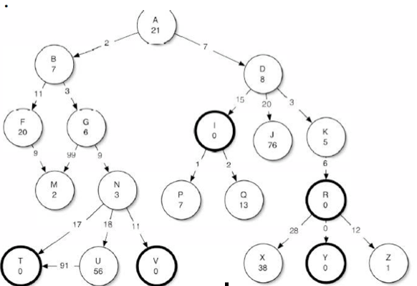
Exercise 5.2: Consider the following state-space, where the goal states are marked with thicker boundaries.

- When performing depth-first search, what is the order of the states that will be searched before you find the first goal state? Give the answer in letters. ABFMG(M)NT (depends whether you include visited nodes / avoid repeated states)
- Do the same for breadth-first search. ABDFGI
- And for depth-first iterative deepening. A – ABD - ABFGDI

Exercise 5.3:
When do you advise to search data-driven (or ‘data-directed’ or ‘forward searching’) instead of goal-driven (or ‘goal-directed’ or ‘backward searching’)?
Data-driven when there are too many goal states, and in case goal states are not explicitly known.
You should also look at the branching factors in both directions. When this size is larger when starting from the Initial State you should, e.g., do goal directed search.

Exercise 5.4:
What are the advantages and disadvantages of breadth-first compared to depth-first searching algorithms? Discuss at least two different aspects.
Breadth-first search guarantees to find a solution (completeness) and the shortest path first (optimality) (note: assumed the branching factor is finite). Depth-first search can get stuck in a search space that is not finite (think of loops). Depth-first has advantages when the searching tree has a high branching factor and is not deep compared to breadth-first search. Depth-first also has a smaller space complexity; O(bm) versus O(b^{d}+1). This is because breadth-first search has to keep all the visited nodes in memory to produce the final solution path, depth-first not.
Depth-First Iterative Deepening combines the best of two worlds. While it takes slightly longer to find the solution, this approach guarantees completeness and optimality, while only using the restricted space complexity of DFS (namely a linear complexity O(bm).

Exercise 5.5:
Give an example of a search tree in which depth-first iterative deepening would be much more expensive (in terms of computing time) to use compared to depth-first search?
A tree in which the solution lies deep under in the left branch of the tree. Take simply A, B, C, D in one branch.

